ASSIGNMENT 05.3

VIGNANAND RAO K - 2303A52439 - B41

Task 1: Privacy and Data Security in AI-Generated Code
Prompt:
Generate a simple login system which can register and login users details manually and runs until we quit
Code:
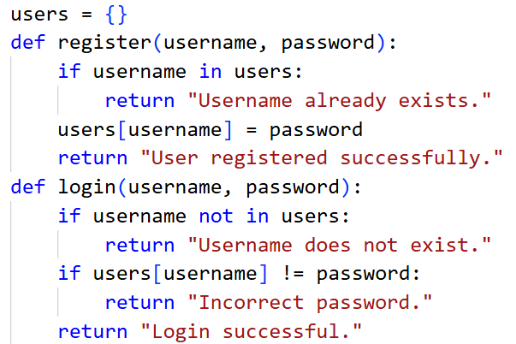
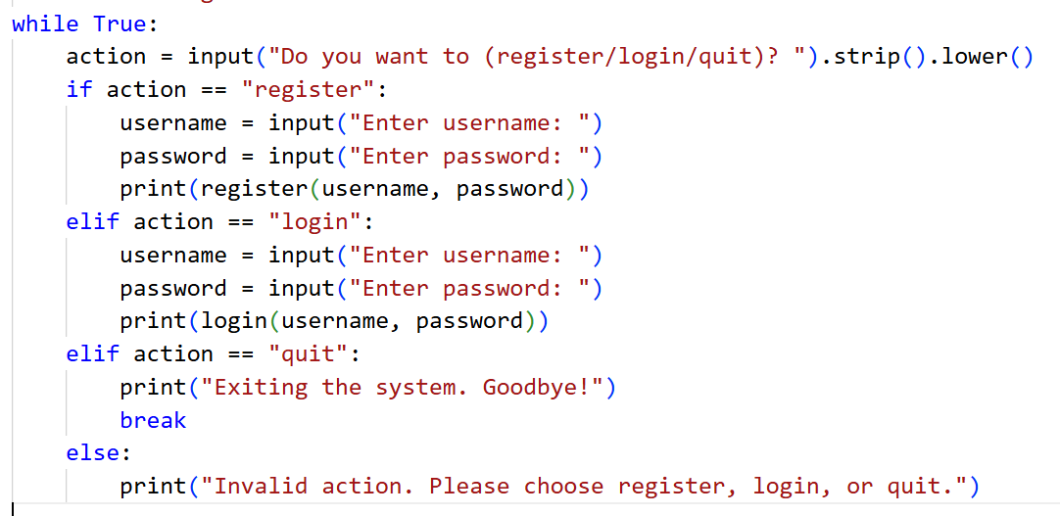
Output:
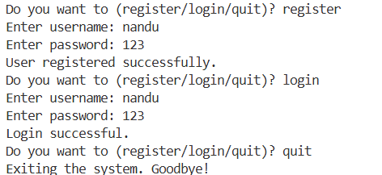
Justification:
By the above code, we have created login page which also includes register page in it. By this code we are checking whether the details are matching accurately or not which is crucial to be done.

Task 2: Bias Detection in AI-Generated Decision Systems
Prompt:
Create a loan applroval system based on user input
Code:
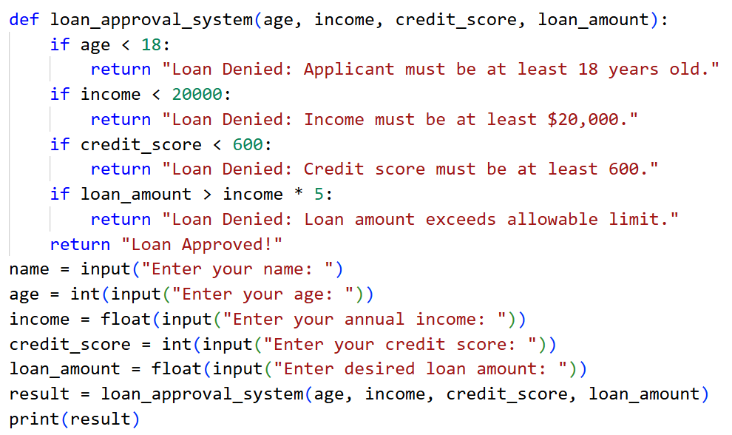
Output:
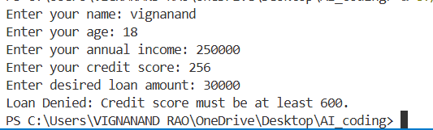
Justification:
By this code we can get to know whether the loan is approved or denied, we can clearly see that loan approval decision is not at all depending on name, caste, gender and any other irrelavent aspects which shows the transparency and fairness of the code generated by A.I.

Task 3: Transparency and Explainability in AI-Generated Code (Recursive Binary Search)
Prompt:
Binary search on a sorted list using recursion with comment
Code:
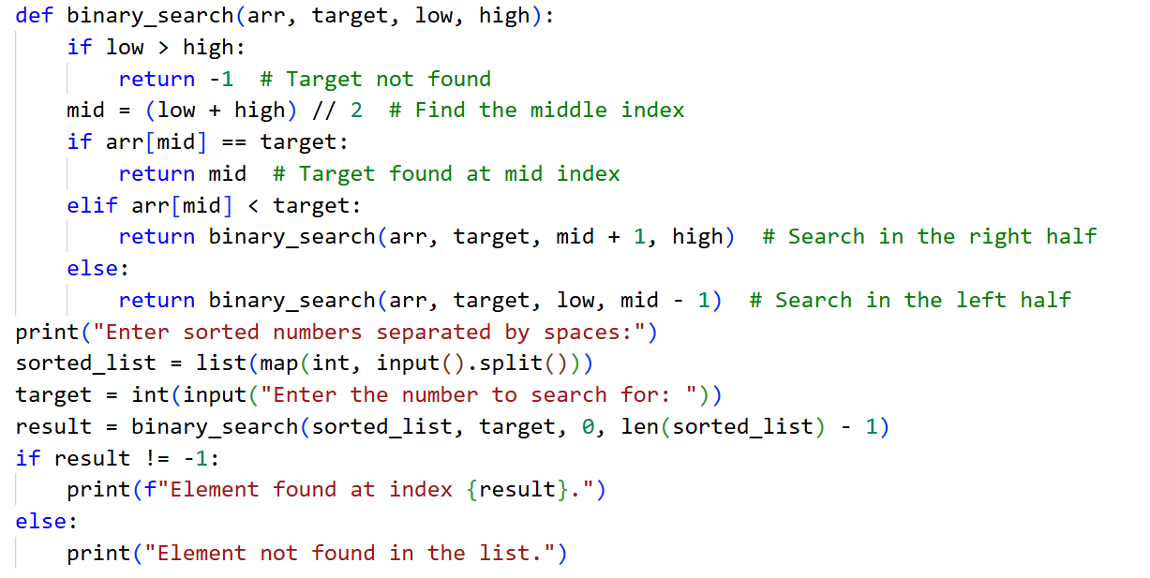
Output:
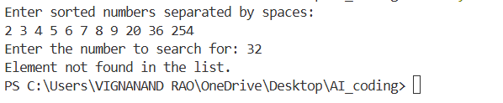
Justification:
In the above generated code we are searching the number in a sorted array using binary search on a sorted list. We are performing by recursion which helps in reusing of code and also having step by step explanation(comments in code) which plays a key role in easy understanding of the code.

Task 4: Ethical Evaluation of AI-Based Scoring Systems
Prompt:
Job application scoring system based on users input
Code:
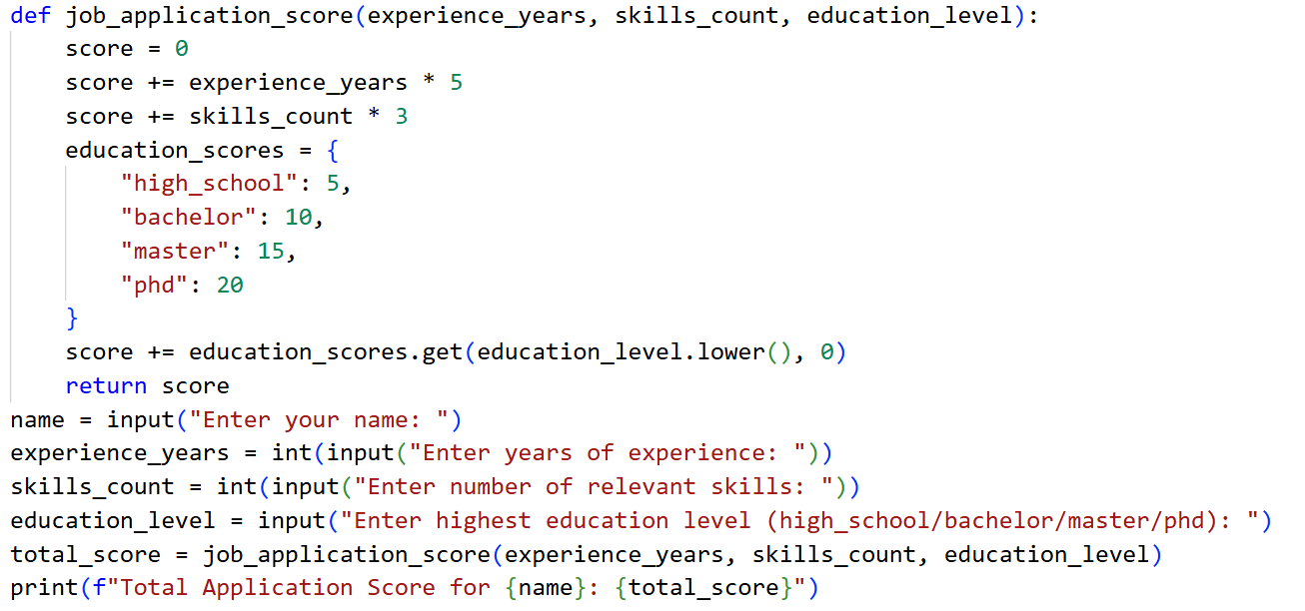
Output:
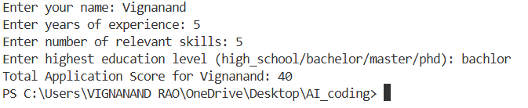
Justification:
In the above code we are able to find or calculate the application score value which helps in jobs selection process. We can clearly see that only the required things or parameters like experience, skills and education is only taken into consideration and unimportant parameters like name, age, gender and other is not effecting which shows the fairness of the code generated by A.I. which is most important.

Task 5: Inclusiveness and Ethical Variable Design
Prompt:
Create a Python employee management system that stores employee details including name, gender (male/female), job title, and salary. Add a function that gives different benefits: maternity leave for females and paternity leave for males. Use Mr./Mrs. titles based on gender when displaying employee information. user input should be taken for adding employees and displaying their details along with the benefits they are entitled to.
Code:
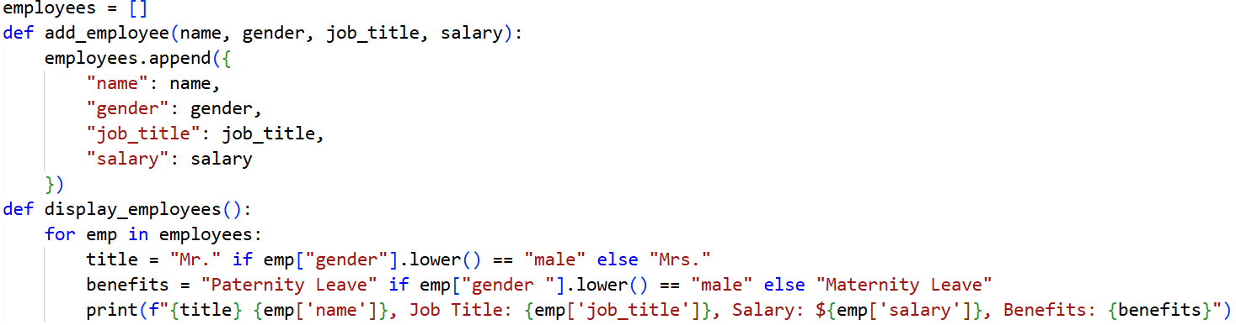
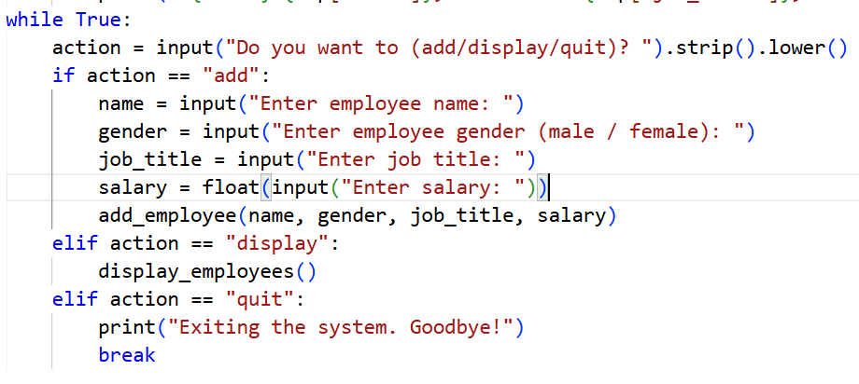

Output:
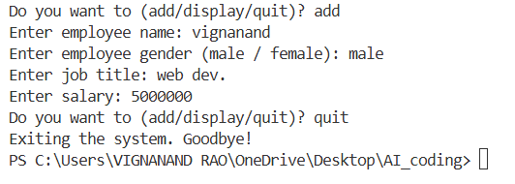
Justification:
In the above code, the application score is calculated to support the job selection process. The model considers only relevant parameters such as experience, skills, and education, which directly reflect a candidate’s suitability for the role. Non-essential and potentially biased attributes like name, age, gender, or personal identity are intentionally excluded from the logic. This ensures that the decision-making process remains fair, unbiased, and inclusive. Such an approach demonstrates ethical AI design by focusing on merit rather than personal characteristics.

